Формулы

tg @ =B/A
ctg @ =A/B
sin @ =B/C
cos @ =A/C

А
α
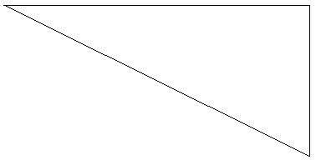

B

β
C

